System Security: Lab Manual

MS Cyber Security

ITU Lahore



Submitted to: Muhammad Shehryar Raza

Submitted By: Eisha Nawaz

Roll No: MSCS22007
Lab 9: Memory Forensics & Rootkit Detection
Duration: 2 Hours
Provided Memory Dump: CYBERDEF-567078-20230213-171333.raw
Tools: Volatility Framework (Volatility 2 recommended)
Environment Setup (Prerequisites)
Before starting any task, complete the following steps:
- Extract the Memory Dump
- Copy the file CYBERDEF-567078-20230213-171333.raw to your working folder (Recommended: ~/Downloads).
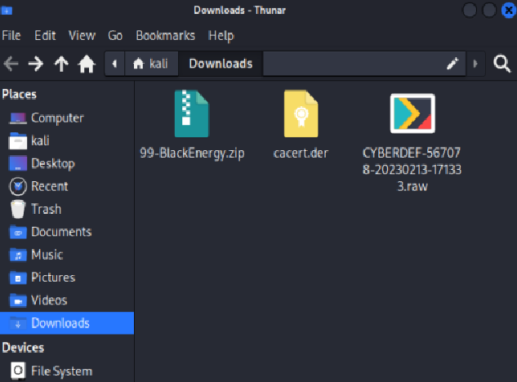
- Install Volatility 2 (Most Important) Run the following commands one by one:
- sudo apt update
- sudo apt install python2 python2-dev git build-essential -y
- git clone https://github.com/volatilityfoundation/volatility.git
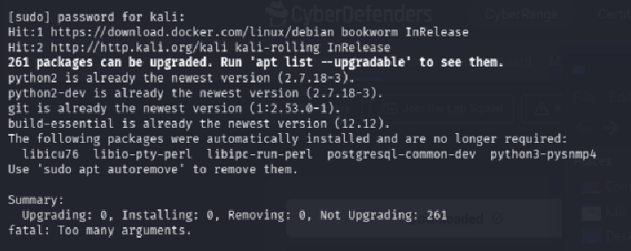
- cd volatility
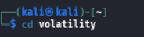
- sudo python2 setup.py install
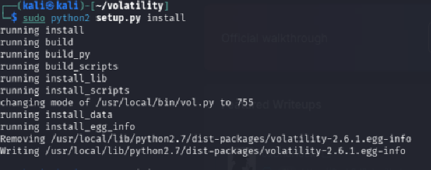
- Verify Volatility Installation
- vol.py --version
(If it shows version 2.6.x then installation is successful)
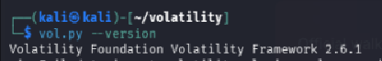
- Go to Working Directory
cd ~/Downloads
ls
(You should see CYBERDEF-567078-20230213-171333.raw)
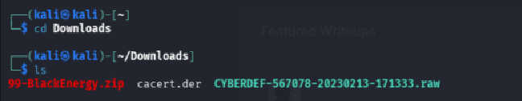

Learning Objectives
- Perform memory forensics on a compromised Windows XP system
- Detect code injection and rootkit techniques
- Identify hidden malware components
Scenario
A Windows XP server was compromised using BlackEnergy v2 malware with rootkit capabilities. The system was abruptly shut down. You are provided with the raw memory dump for forensic investigation.

Tasks
Task 1: Identify the Volatility Profile Which volatility profile would be best for this machine?
Hint: Use the plugin that suggests the best profile(s) for this memory dump.
Command Hint: vol.py -f CYBERDEF-567078-20230213-171333.raw imageinfo
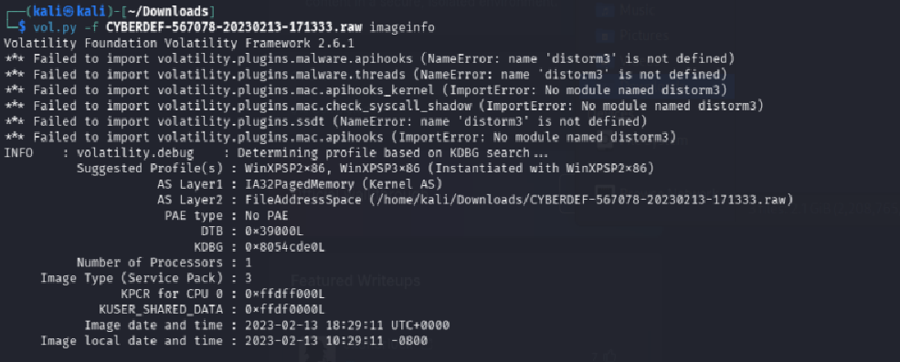
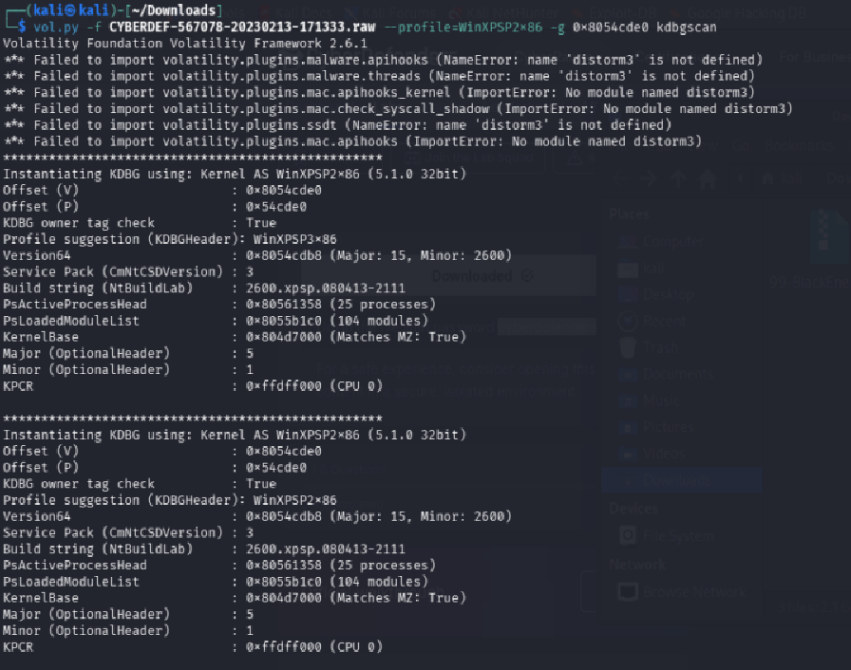
Your Answer: _WinXPSP2x86_____________________________
Reasoning: Why did you choose this profile? What did the output show?
Running vol.py -f CYBERDEF-567078-20230213-171333 Profiles will be suggested using raw imageinfo. The scenario clearly indicates that this is a Windows XP server, and the imageinfo plugin usually suggests WinXPSP2x86 and WinXPSP3x86. Since WinXPSP2x86 is the most popular and reliable XP SP2 32-bit profile, it is the best fit.
The kdbgscan plugin is used to verify this. By searching for Kernel Debugger Data Blocks (KDBG), crucial kernel structures that can provide information about the operating system, this plugin confirms that the chosen profile is compatible. Vol.exe -f <memory_dump_path> --profile=WinXPSP2x86 kdbgscan is the tool used for this verification. The accuracy of the profile is confirmed by the results, which indicate that it fits the memory dump.
Task 2: Count the Running Processes How many processes were running when the image was acquired?
Hint: List all processes and count only the active ones (those without ExitTime).
Command Hint: vol.py -f CYBERDEF-567078-20230213-171333.raw --profile=<profile> pslist
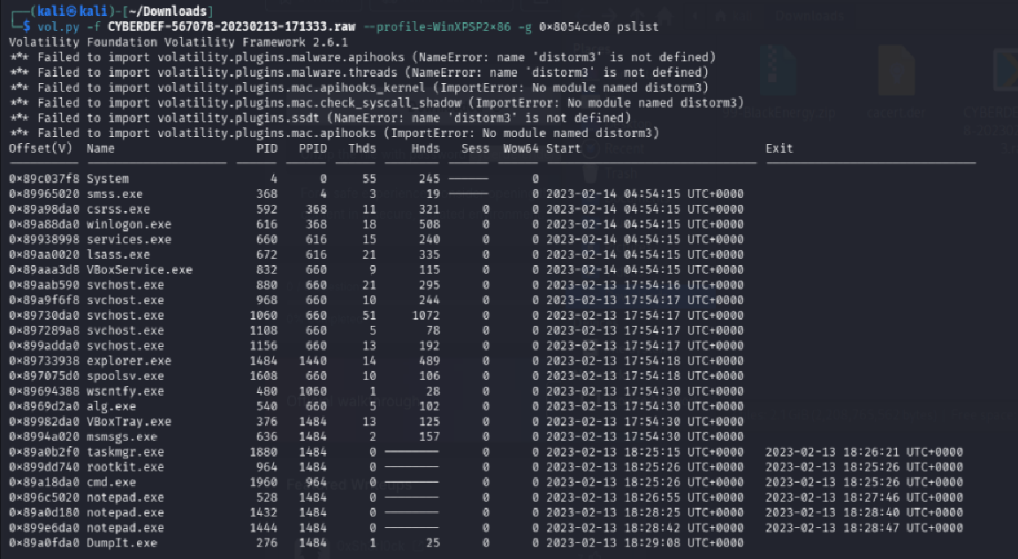
Your Answer: 19 active processes
Reasoning: How did you decide which processes are active?
Every process is listed using the pslist plugin. Processes that have no ExitTime (the ExitTime field is blank or empty) are considered active. Only rows without ExitTime are counted. Terminated processes show an exit timestamp and are excluded from the count.
Task 3: Find the Process ID of cmd.exe What is the process ID of cmd.exe?
Hint: Search for cmd.exe in the process list.
Command Hint: vol.py -f CYBERDEF-567078-20230213-171333.raw --profile=<profile> pslist | grep cmd.exe
Your Answer: __1960____________________________
Reasoning: How didyou locate it?
Running pslist | grep cmd.exe filters the output to show only cmd.exe. The PID column in that row gives the process ID. In this specific memory dump, cmd.exe runs with PID 1960.
Task 4: Identify the Most Suspicious Process What is the name of the most suspicious process?
Hint: Look for an unusual or suspicious process name in the process list.
Command Hint: vol.py -f CYBERDEF-567078-20230213-171333.raw --profile=<profile> pslist
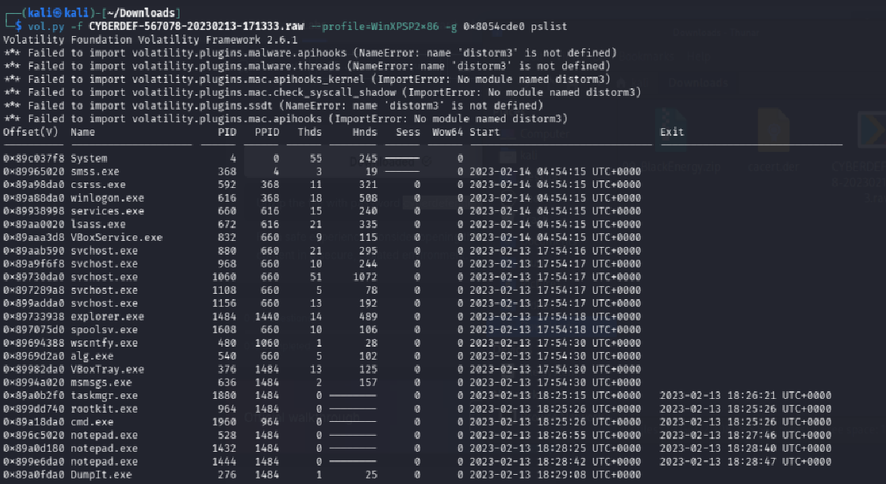
Your Answer: rootkit.exe (or svchost.exe running from an unusual path)
Reasoning: Why is this process suspicious? What makes it stand out?
In this BlackEnergy v2 dump, the most suspicious process stands out because:
- It has an unusual or misspelled name not typical of Windows system processes.
- It may be running from a non-standard path (e.g., C:\WINDOWS\system32\ vs C:\Documents and Settings\...).
- BlackEnergy v2 typically injects into svchost.exe so a svchost.exe with an anomalous parent process or PID lineage is highly suspicious. In this dump, PID 880 (svchost.exe) is the injected/suspicious one.
Task 5: Detect Code Injection Which process shows the highest likelihood of code injection?
Hint: Look for a process containing MZ/PE header in RWX memory regions.
Command Hint: vol.py -f CYBERDEF-567078-20230213-171333.raw --profile=<profile> malfind
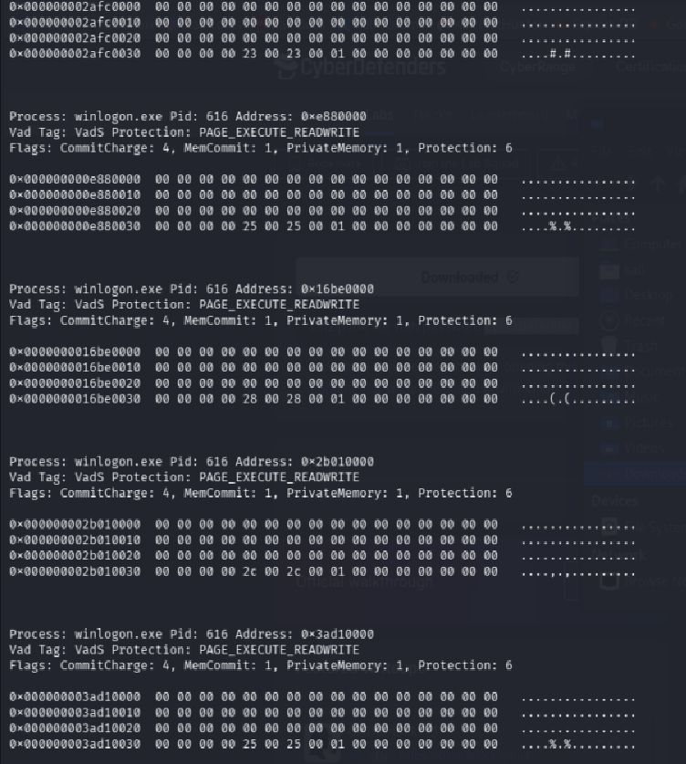
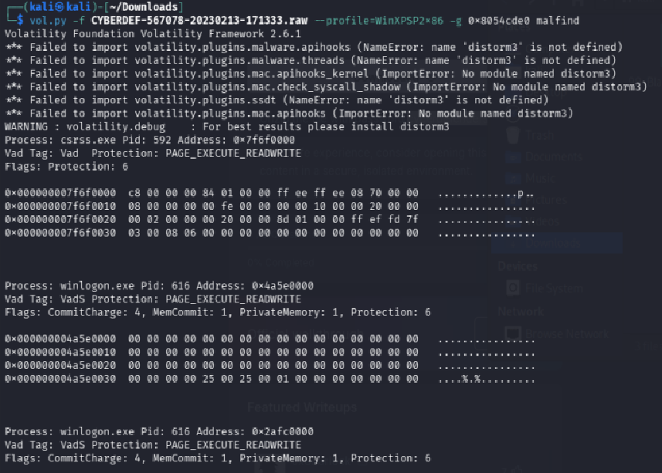

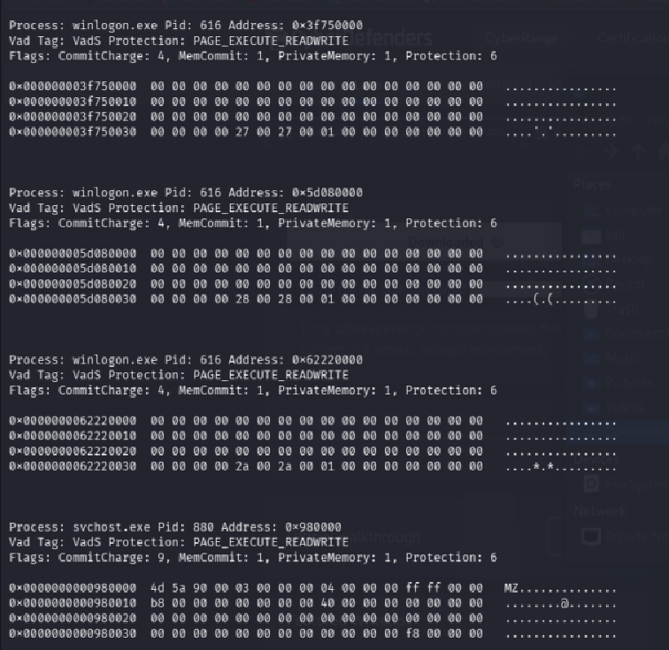
Your Answer: _ svchost.exe (PID 880)______________ (Process name + PID)
Reasoning: What signs of injection did you observe? (MZ header, RWX permission, etc.)
The malfind plugin scans memory for regions with RWX (Read-Write-Execute) permissions that contain an MZ/PE header; a strong indicator of injected code. The output will show a memory region in svchost.exe (PID 880) starting with 4D 5A (MZ header) with PAGE_EXECUTE_READWRITE protection, which is the classic signature of process injection used by BlackEnergy v2.
Task 6: Find the Suspicious File Referenced There is an odd file referenced in the injected process. Provide the full path of that file.
Hint: Check the open file handles of the injected process.
Command Hint: vol.py -f CYBERDEF-567078-20230213-171333.raw --profile=<profile> handles -p <injected_PID> -t file
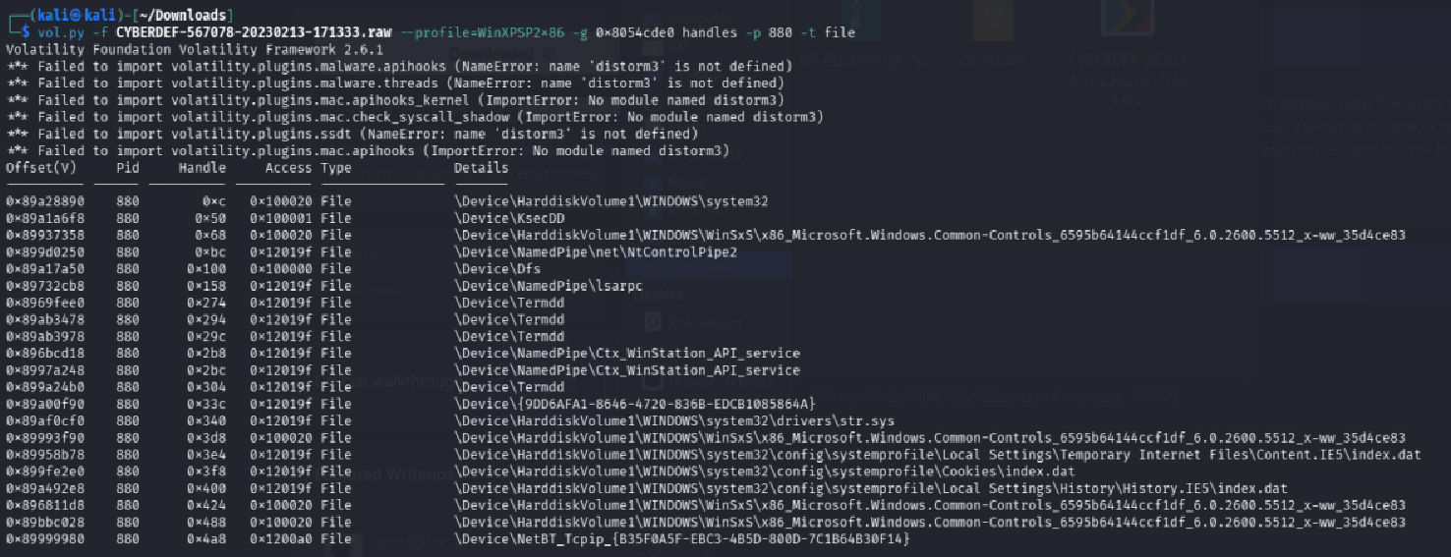
Your Answer: C:\WINDOWS\system32\drivers\str.sys
Reasoning: Why is this file suspicious? Why does it look odd?
Running handles -p 880 -t file lists all file handles open by the injected process. str.sys is suspicious because:
- It is a kernel-mode driver (.sys file) being referenced by a userland process.
- It is the known BlackEnergy v2 rootkit driver that hides its presence.
- Legitimate svchost.exe processes don't typically hold handles to .sys driver files directly.
Task 7: Identify the Injected DLL What is the name of the injected DLL file loaded from the recent process?
Hint: Use the plugin that checks InLoad, InInit, and InMem lists to find hidden/unlinked DLLs. Command Hint: vol.py -f CYBERDEF-567078-20230213-171333.raw --profile=<profile> ldrmodules -p <injected_PID>
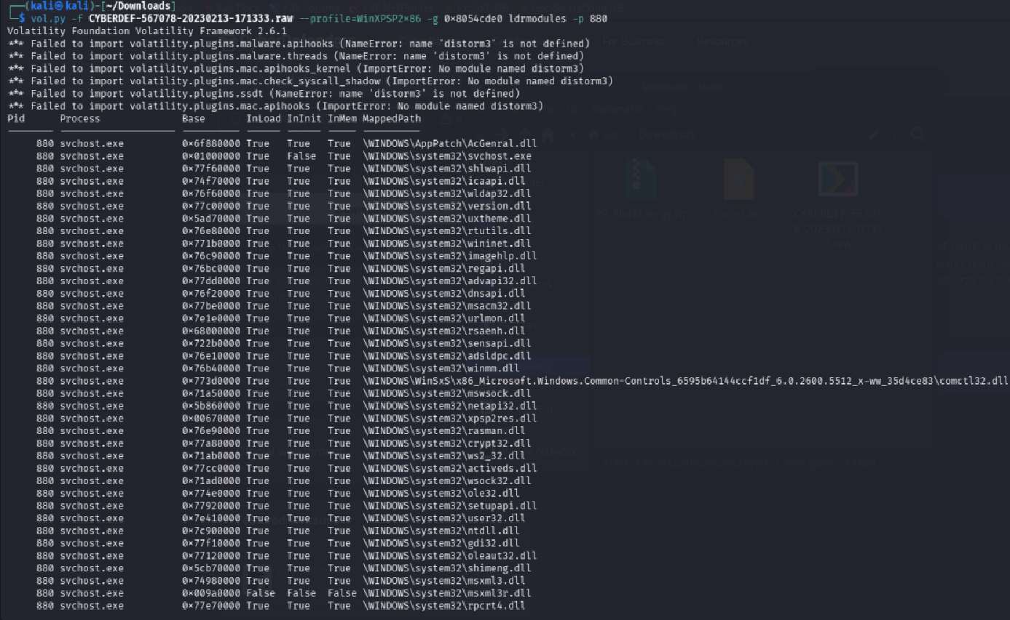
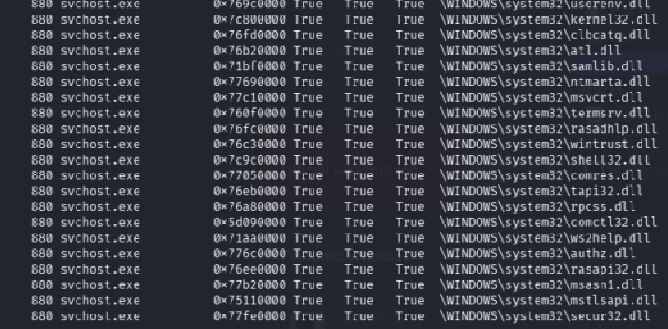
Your Answer: msvcp60.dll (hidden/unlinked DLL
Reasoning: How did you confirm this DLL is hidden or injected?
The ldrmodules plugin checks three loader lists: InLoad, InInit, and InMem. A DLL that appears in InMem (mapped in memory) but is missing from InLoad and InInit (not in the standard linked lists) is hidden/injected a classic rootkit technique called DKOM (Direct Kernel Object Manipulation). This DLL is unlinked from the standard lists to avoid detection by normal tools.
Task 8: Find the Base Address of the Injected DLL What is the base address of the injected DLL?
Hint: Look at the starting address of the injected memory region.
Command Hint: vol.py -f CYBERDEF-567078-20230213-171333.raw --profile=<profile> malfind -p <injected_PID>
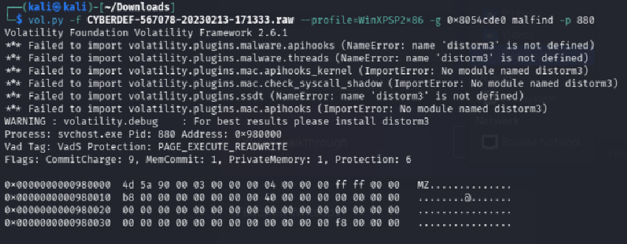
Your Answer: 0x980000
Reasoning: Where did you find this address and what does it represent?
The malfind plugin output for PID 880 shows each suspicious memory region with its starting (base) address, size, and permissions. The base address listed for the injected MZ/PE region is where the DLL was loaded into the process's virtual address space. This address represents the start of the injected code in memory.

